Lab 06

Common Emitter Transistor Amplifier
Name: Syed Sualeh Abbas | Student ID: 10303

Objective
To investigate the performance of single-stage common emitter BJT amplifier

Introduction to BJT Amplifiers
One of the most useful applications of a transistor is amplification. With an amplifier, the output sinusoidal signal can be achieved greater than the applied input sinusoidal signal. When BJT is operated in active mode, changes in base-emitter voltage gives rise to change in collector current. Voltage amplification is obtained utilizing this effect.
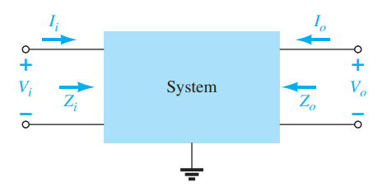
Figure 1: Two-port network representation of amplifier showing its parameters
Biasing (application of DC voltage) is required to make BJT operate in active mode at desired operating point before AC signals are applied for amplification. The superposition theorem is applicable for the 3analysis, permitting the separation of the analysis of the DC and AC responses of the system. In other words, one can make a complete DC analysis of a system before considering the AC response. Once the DC analysis is complete, the AC response can be determined using a complete AC analysis.

Pre-Lab Task

Task 1:
- What is the significance of small signal analysis in transistor amplifiers?
- Why are Coupling and Bypass Capacitors used? Discuss their behavior during AC and DC input signals.
- List down the advantages and applications of CE Amplifiers.

We forgot to take picture of checked prelab. But we got 4 marks.

Common Emitter Transistor Amplifier
Common emitter amplifier configuration is widely used. It provides large voltage gain (typically ten to hundreds) and moderate input and output impedance. CE amplifier circuit is shown in Figure 2.
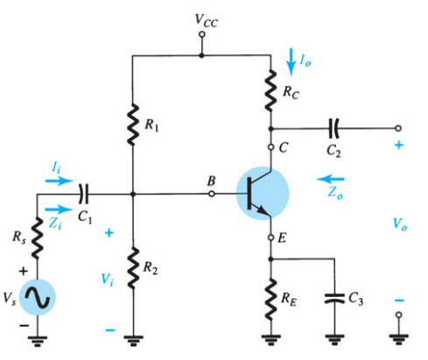
Figure 2: Common-emitter BJT amplifier circuit
Using a DC source and biasing configuration, the BJT is first biased to establish operating point in active region. Then, AC signal Vs is applied at input port through a capacitor. The source resistance is Rs here which will be neglected in our analysis for now. So, applied input to amplifier Vi is source voltage. The output voltage Vo is measured from collector terminal. The capacitors C1 and C2 are called coupling capacitors. The emitter resistor is bypassed through C3 bypass capacitor for AC signal.
For a particular DC operating point, when AC input signal vi is superimposed on DC voltage V_{BE}, the corresponding instantaneous curve of base-emitter voltage is shown with instantaneous base current. The corresponding instantaneous collector-emitter voltage is represented in i_{c}-v_{ce} curve which shows large variation in collector voltage by small changes in applied input AC voltage. The amplification is obtained at output node i.e. collector. From this, you can see the importance of locating Q point of BJT. If V_{CE} is very small, the BJT will enter saturation region as output voltage swings across it and if closer to Vcc, it will enter cut-off region. The location of bias point should allow swing in both directions equally, otherwise, output waveform peaks (positive or negative) will be clipped.
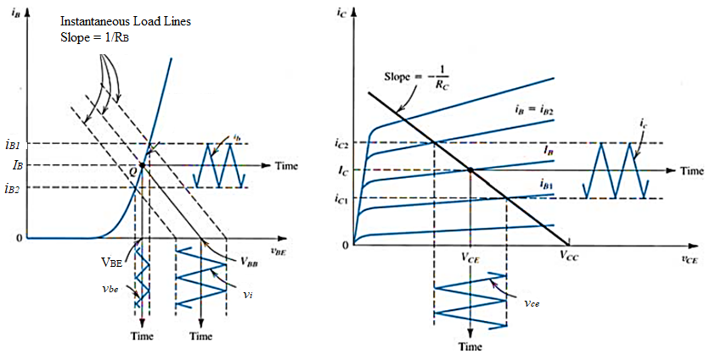
Figure 3: Graphical representation of AC signal components superimposed on DC
DC analysis has been covered in previous labs. For AC analysis, equivalent models are used. Here, for CE configuration r_{e} model will be used as shown in Figure 4.
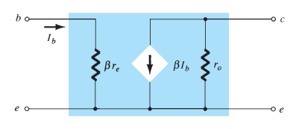
Figure 4: BJT AC equivalent model for CE configuration
Moreover, the AC equivalent of complete transistor network is obtained by:
- Setting all dc sources to zero and replacing them by a short-circuit equivalent
- Replacing all capacitors by a short-circuit equivalent
- Removing all elements bypassed by the short-circuit equivalents introduced by steps 1 and 2
Using the equivalent model of BJT, the AC equivalent of the network shown in Figure 2 is drawn in Figure 5.
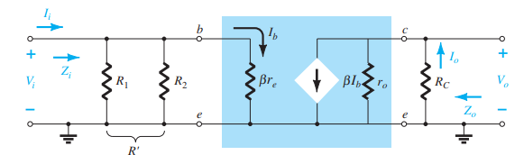
Figure 5: AC equivalent of CE amplifier network shown in Figure 2

Characteristic Parameters of Common Emitter Amplifier
The characteristic parameters of an amplifier include its voltage gain Av, input impedance Zi, output impedance Zo and current gain Ai.
Transistor AC dynamic resistance r_{e} shown in model can be calculated as
- AC Voltage Gain Av is defined as
Here, Vo and Vi are output and input voltage which can be measured as rms, peak or peak-to-peak.
From model, the AC voltage gain of a CE amplifier (under no-load) can be calculated using:
With bypass capacitor, use R_{E} =0 in the above equation which results in
- AC Input Impedance, Zi, is that of the amplifier as seen by the input signal. For CE amplifier, it can be given as
- AC Output Impedance, Zo, for CE amplifier can be approximated to

Task 2: To perform DC analysis for CE BJT Amplifier
- For the common-emitter amplifier circuit shown in Figure using BJT model 2N3904, perform DC analysis to complete Table 1. The supply voltage V_{CC} is 20 V. Before, performing DC analysis identify the BJT bias configuration and verify the conditions that should be satisfied for of the chosen analysis. Use DC Gain β equal to 300 in your calculations if needed.
The circuit component values are given here:
R_{C} =3kΩ, R_{E}=1kΩ, R₁=33kΩ, R₂=10kΩ, C₁= C₂=15μF and C₃=100μF.

Table 1: DC analysis of Common-Emitter BJT amplifier
Resistances | Measured* | DC Parameters | Calculated | Measured
R_{C} | 2.94k | V_{B} | 4.58V | 4.44v
R_{C} | 2.94k | V_{E} | 3.88V | 3.76v
R_{E} | 0.98k | I_{E} | 3.96mA | 3.44mA
R_{E} | 0.98k | V_{C} | 8.36V | 8.83v
R₁ | 33.02k | I_{C} | 3.96mA | 3.78mA
R₁ | 33.02k | I_{B} | 13.5uA | 18uA
R₂ | 9.82k | DC Gain β | 300 (Given) | 210

- Now, implement the circuit and verify the DC analysis by measuring the values for all the DC parameters listed in Table 1.

Task 3: To perform AC analysis for Common Emitter BJT Amplifier
For the same circuit, now perform AC analysis and calculate the parameters listed in Table 2. Use measured values in your calculations for AC analysis and fill in second column.

Table 2: AC analysis of Common-Emitter BJT amplifier
Characteristic Parameters | Calculated Values | Measured Results
Transistor AC Dynamic Resistance: r_{e} | 7.56 | 7.54
Input Impedance: Z_{i} | 1.33k | 1.074k
Output Impedance: Z_{O} | 2.94k | 3.1k
AC Voltage Gain: A_{V} | -389 (180 phase shift) | -403.3

Task 4: To implement Common Emitter Amplifier Circuit
- In the implemented circuit, now apply AC signal of magnitude 50mV pk sine wave at 1k Hz through coupling capacitor of 15μF.
- Use bypass capacitor of 100μF at emitter and measure the output voltage through another coupling capacitor of 15μF as shown in Figure 2. This is the unloaded output of amplifier as there isn’t any load resistor connected at the output terminal of amplifier. Write down your observations in Table 3.
- Observe the output voltage waveform. Analyze the magnitude and phase of this amplifier output voltage with respect to the applied AC input signal.
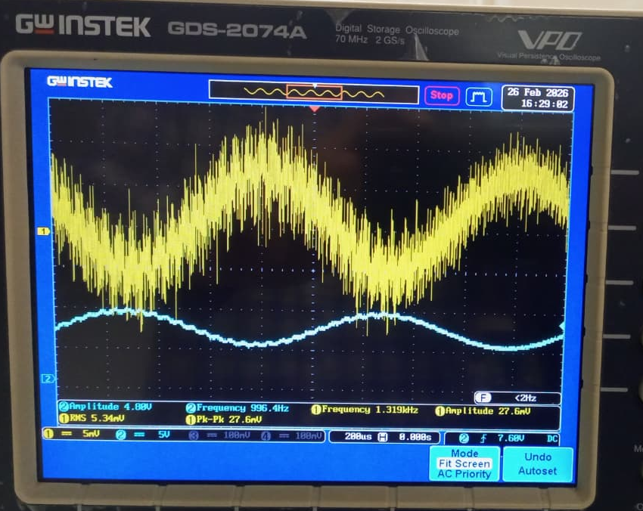
The gain of output voltage is about 177 times more than the AC input. And the phase shift in input output is about 180 degrees.

Task 5: To experimentally determine the characteristic parameters of CE amplifier
The CE amplifier characteristic parameters discussed in Section 6.5 will now be experimentally determined and compared with the ones calculated in Task 3.

Amplifier Voltage Gain: Av
- Using the measured values of input and output voltages of the amplifier, determine the magnitude of amplifier voltage gain and note it down in Table 2.
- Keeping the phase difference in mind, assign its sign (+/-).

Amplifier Input Impedance: Zi
- To determine the input impedance of this amplifier, connect an input measurement resistor, Rx=1kΩ, as shown in Figure 6. Apply the same input signal (50mVpk at 1 kHz) but this time through this known resistance. Measure Vi i.e., the signal after this resistor Rx. Note down in Table 3.
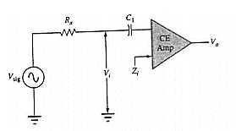
Figure 6: Circuit for determining input impedance

- Mathematically, for this circuit this voltage Vi can now be expressed as
Solve the given equation for Zi.
$\frac{V_{i}R_{X}}{V_{sig}-V_{i}}$
- Determine the value of input impedance. Note down in Table 2.
Table 3: Data table for experimental determination of CE amplifier characteristic parameters
Characteristic Parameter | Required Measurements | Measured Values
For CE Amplifier Voltage Gain | Input Voltage: Vi | 52mv (Vpp)
For CE Amplifier Voltage Gain | Output Voltage (Unloaded): Vo | 12.2V
For CE Amplifier Input Impedance | Measurement Resistor: Rx | 0.98k
For CE Amplifier Input Impedance | Source Voltage: V_{Sig} | 78mV
For CE Amplifier Input Impedance | Input Voltage: Vi | 41mV
For CE Amplifier Output Impedance | Output Voltage Unloaded: Vo | 12.2V
For CE Amplifier Output Impedance | Load Resistor: R_{L} | 2.97k
For CE Amplifier Output Impedance | Output Voltage Load: V_{L} | 6.1V

Amplifier Output Impedance: Zo
- Remove the input measurement resistor Rx.
- Apply AC input signal (50mV pk at 1 kHz) directly. Measure the unloaded output voltage Vo.
- Now, connect load resistor of 3kΩ (use measured resistance) and measure the corresponding loaded output voltage. Note it down in Table 3.
- When loaded, the output voltage can be expressed as
Solve the above for output impedance Zo.
- Calculate the output impedance to complete Table 2.

Task 6: To investigate the performance of CE amplifier
- Using the data collection of Table 2, compare the estimated and measured characteristic parameters. What are your comments about the approximations considered in the analysis?
The value of $r_{e}$is almost the same (7.56 Ω calculated and 7.54 Ω measured), which shows that the small signal approximation works well.
There is a small difference in input impedance and output impedance. This can happen because of resistor tolerances, transistor parameter variations, and internal transistor effects which are not included in the theoretical analysis.
The voltage gain calculated is −389 while the measured value is −403.3. The negative sign indicates a 180° phase shift between input and output, which is expected for a common emitter amplifier.
- Now, in the actual CE amplifier circuit where there is no output load or input measurement resistance connected in the circuit having the applied input of 50mVpk sinewave at 1k Hz, obtain the output voltage waveform and observe this output as you gradually increase the input signal voltage from 50mV to 200mV. Analyze the changes you observe in amplifier output voltage waveform.
When the input signal was increased from 50 mV to 200 mV, the output voltage also increased because of the amplifier gain.
However, at higher input levels the output waveform started showing distortion and clipping. This happens because the transistor begins to move out of the active region and enters cutoff or saturation during part of the signal cycle.

- Try measuring the output before the coupling capacitor connection at output node. Justify the need of coupling capacitor?
When the output was measured before the coupling capacitor, the waveform had a DC offset along with the AC signal. This is because the collector has a DC bias voltage.
The coupling capacitor blocks the DC component and only allows the AC signal to pass to the output. Therefore, it prevents the DC bias of this stage from affecting the next stage.

- If you increase the resistor at collector terminal to 5kΩ, what changes do you observe in the output voltage waveform? Justify your analysis. Hint: Observe the DC operating point Vc too to relate.
When the collector resistor $R_{C}$was increased from 3 k to 5 k, the voltage gain increased because gain is approximately proportional to $R_{C}$.
However, increasing $R_{C}$also reduced the collector DC voltage $V_{C}$. This shifts the operating point and reduces the available output swing, which may cause earlier clipping of the output waveform.

6.6. Post Lab Task

Task 7: To calculate current of the CE amplifier
- Find the current gain of the amplifier implemented in lab when it is loaded.
Io​≈2.05mA
$$I_{i}=\frac{0.041}{1074} \\ I_{i}≈38\text{ µ}A$$
Current gain:
$$A_{i}=\frac{2.05mA}{38\text{µ}A} \\ A_{i}≈54$$
- From voltage gain and current gain, one can say that the output AC power is greater than the input AC power. How can you justify this when conservation of energy dictates that over time the total power output, Po, of a system cannot be greater than its power input, Pi, and that the efficiency defined by efficiency cannot be greater than 1?
The output AC power can be larger than the input AC power because the amplifier takes additional power from the DC supply $V_{CC}$. The input signal only controls the transistor, while the actual energy delivered to the output comes from the power supply. Therefore, conservation of energy is not violated

Assessment Rubric
Lab 06
Common Emitter Transistor Amplifier
Name: | Student ID:

Points Distribution

Task No. | LR1 / LR2  Simulation / Circuit  36 | LR 4  Data Collection  16 | LR 6  Calculation  24 | LR 10  Analysis  20
Task 1 | - | - | - | /4
Task 2 | /8 | /4 | /8 | -
Task 3 | - | - | /8 | -
Task 4 | /8 | /4 | - | -
Task 5 | /12 | /4 | /4 | -
Task 6 | /8 | /4 | - | /8
Task 7 | - | - | /4 | /8
CLO Mapped | CLO 1 | CLO 1 | CLO 1 | CLO 1
Total

Affective Domain Rubric |  | Points | CLO Mapped
AR 4 | Report Submission | /4 | CLO 4

CLO - LDL | Total Points | Points Obtained
CLO 1 – (Psy-3) | 96
CLO 4 – (Aff-3) | 4
Total | 100

For description of different levels of the mapped rubrics, please refer the provided Lab Evaluation Assessment Rubrics and Affective Domain Assessment Rubrics.

